**Aws Assim Mustafa** 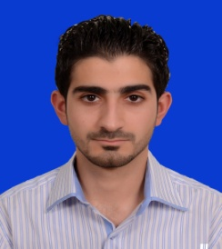

Erbil, MRF Towers, IRAQ

Telephone: +9647508460874

[aws.alzubaidi91@gmail.com](mailto:aws_gladiator@hotmail.com)

**Personal Information:**

Marital Status: Single

Gender: Male

Age: 27

Citizenship: Iraqi

**Career Objective:**

Primary: English Tutor

Secondary: English-Arabic or Vice Versa Translator

**Education:**

Cihan University, Department of English Language

Degree: Bachelor of Arts in English Language.

Erbil-Iraq (July 2011- July 2015)

University Putra Malaysia (UPM), Department of English Language

Degree: Master of Applied Linguistics.

Selangor- Malaysia (September 2016- June 2018)

**Experience:**

English-Arabic & Vice Versa Translator (Erbil-Iraq, Full Time) November 2015 – August 2016

GCN Company

English-Arabic & Vice Versa Translator (Erbil-Iraq, Part Time) April 2014 – October 2015

TaJ Translation Bureau

English-Arabic & Vice Versa Translator (Erbil-Iraq, Part-Time Volunteer) June 2013- April 2014

Rwanga Private Charity Organization

Online English-Arabic & vice Versa Translator (Baghdad-Iraq, Part-Time) February 2016- January 2018 Al-hikmah Institute for computer sciences, foreign languages and Translation

English Tutor: Teaching English as a Foreign Language to Arabic Students

Private Classes (Erbil-Iraq, Part Time)

**Skills:**

Highly skilled in performing English into Arabic translation (Oral and Written)

Proficient user in Microsoft Office Word, Excel and Power Point

Good working experience in Adobe Acrobat and Photoshop

Proficient user in Microsoft Windows 7, 8 and 10 operating systems

Excellent skills in data entry with ability to type 60 Word Per Minute

**References Available Upon Request**